**IoT Based Smart water Management**

**A Project report submitted in partial**

**fulfilment of the requirements for the**

**degree of B.Tech-Informatoin and**

**Technology**

**By,**

**T. Ramyabharathi(513221205014)**

**Under the supervision of**

**Professor & HOD**

**Department of B. Tech- Informatoin**

**Technology**

Smart Water Management

**PHASE-1 PROBLEM DEFINITION AND DESIGN THINKING**

**Problem statement**

**Design Thinking approoach**

**Problem statement:**

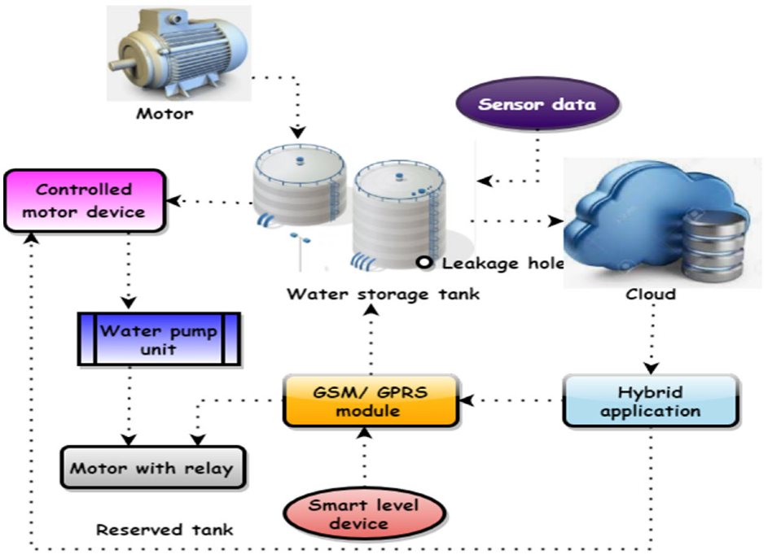

In the 21st century, there were lots of inventions but at the same time were pollutions.

Global warming and so,

on are being formed, because of this there is no safe

drinking water for the world’s pollution. Nowadays, water

quality monitoring in real time faces challenges because of

global warming limited water resources, growing

population, etc. Hence there is need of developing better

methodologies to monitor the water quality parameters in

real time. The monitoring of water quality is extremely

important for maintaining the safety of water resources used

for various purposes.

IoT is progressing with millions of things

connecting each day to generate large amount of

information .

(Internet of Things) based water quality monitoring has been

proposed. In this project, we will implement the design of

IOT for monitoring system that monitors the quality of

water in real time.

*A. Micro Controller-* TheAtmega328isa one of thevery popular

microcontroller chip produced by Atmel It is

an 8 -bit microcontroller that has32Kof flash memory,1K Of EEPROM,and2K ofSRAM.The Atmega328 is one of the microcontroller chips that are used with the

popular Arduino boards.This microcontroller

hasanalogpin and digital pin for easy interface of the

=MicrocontrollerOperating Voltage: – 1.8 - 5.5V23

Programmable I/OLinesTwo 8-bit Timer/CountersReal

Time Counter with Separate OscillatorSix PWM Channels6-

channel 10-bit ADC .

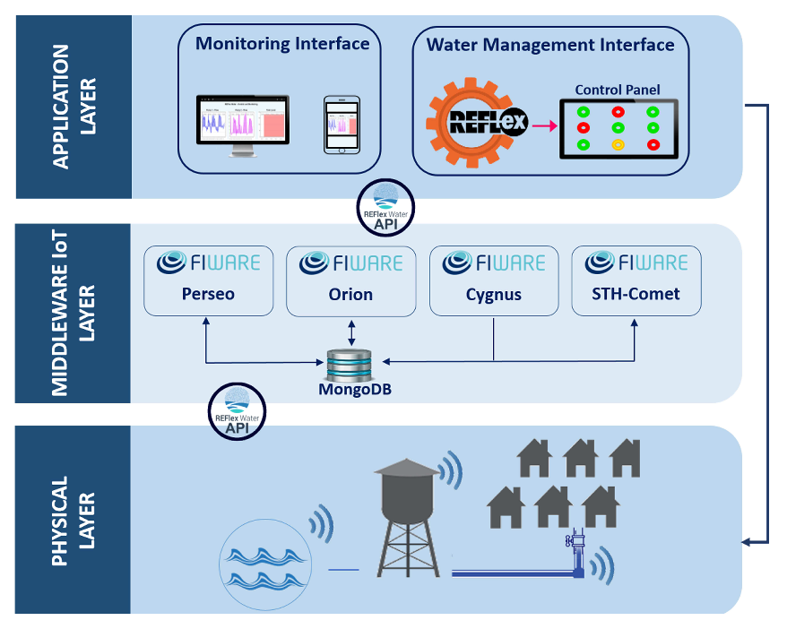

*B.IOT Module*

Wi-Fi Direct (P2P), soft-APIntegrated TCP/IP protocol

stack+19.5dBm output power in802.11b modeSupports

antennadiversityPower down leakage current of <10Ua

Integrated low power 32-bit CPU could be used as

application processorSDIO 2.0, SPI, UARTWake up and

transmit packets in <

2msStandby power consumption Operating Voltage :

Is exceed and it is burn the esp module. GND is connected to

the ground terminal. Rx pin is the receiver pin UART serial

communication The Tx pin is a transmitter. GPIO general

purpose input and output .Reset pin reset the module apply in

3.3v. the CH-PD pin configure channel.

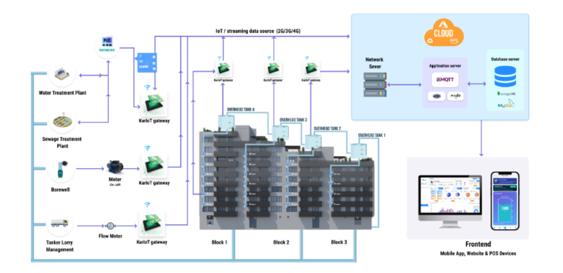

**Design Thinking approach**

**MISO** pins on both the master and slave are ties together.

Even though the Signal in MISO is produced by the Slave,

the line is controlled by the Master . The Master generates a

clock signal at SCLK and is supplied to the clock input ofthe slave. Chip Select (CS) or Slave Select (SS) is used to select a particular slave by the master.

Master – Out / Slave – In or MOSI, as the name suggests, is

the data generated by the Master and received by the Slave.

Hence, MOSI pins on both the masterand slave are

connected together. Master – In / Slave – Out or MISO is

the data generated by Slave and must be transmitted to

Master.

Configuration of nRF24L01

RF24 radio (CE, CS) --- mention the pin connection

Mention the pipe address

Uint64_t pipe = 0xE8E8F0F0E1LL

Radio.begin (); Start the process

Radio.openWritingPipe (pipe)

Radio.write(msg,1); Radio.startlistening();

Radio.available() – to check any incoming message.

B. pH Sensor

PH sensor used to determine the pH value content in the

Water . The pH value range from the acidity – Neutral –

Alkaline. It has two rod to measure the value of the pH

value in the water. The pH meter is used for the quality

check if water is safe for drinking. A balanced pH level is

very important for human health; it should be

approximately equal to 7. It gives Full range pH reading .

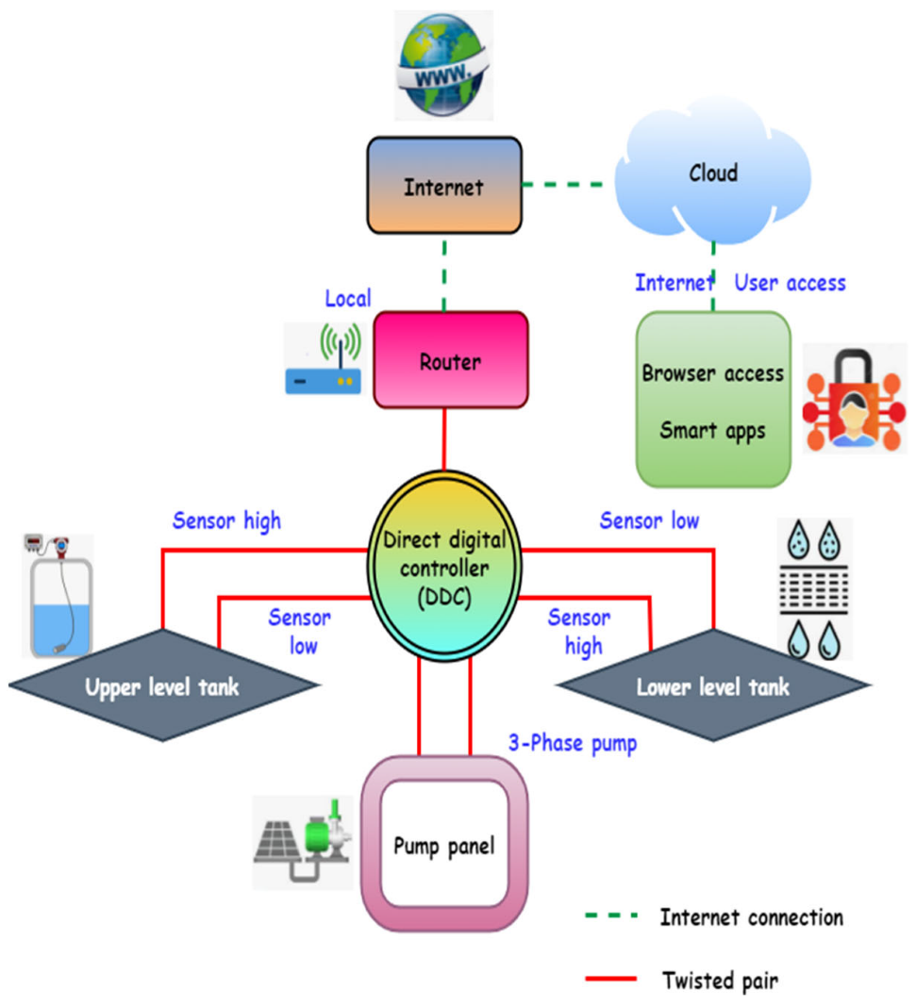

It is used to monitoring the salt content of the sewage water

and communicate with microcontroller for posting this

information to internet. It has consists of two rods one is

reference rod and measuring rod. The voltage is given to the

reference rod and the conducting current passes to

measuring rod. The voltage present in the measuring rod is

proportional to the salt content of the water.

The turbidity sensor SKU: SEN0189 is used to detect

water quality by measuring level of turbidity. The

turbidity sensor enables the detection of suspended

particles in water.

To the microcontroller unit (MCU). The threshold is adjustable by

adjusting the potentiometer in digital signal mode. The operating

voltage of the turbidity sensor is 5V DC and the operating current

is 40mA (max) respectively.

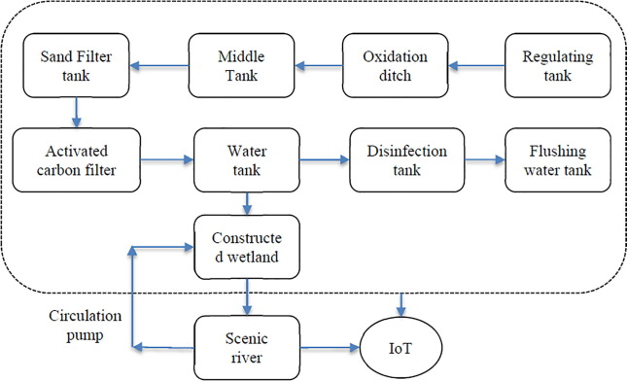

The circuit diagram consist of microcontroller, IoT module,

wireless Trance receiver, buzzer. This circuit is used to post

the data to the internet by collecting the data from industrial

sewage waste monitoring system. The wireless Trance

receiver module is connected to the pin number of

microcontroller D8 to D13.

IOT module is connected to the microcontroller in

pin number of d2 d3. The module split the data from

microcontroller to internet through Wi-Fi router. IOT

module device consist of TCP/ IP self-supported

programming module can include header and trailer frame

format. From microcontroller data send to module is pre

processed in HTML language.

This transceiver module is send to data to microcontroller

through serial format with address. The program

used in the

microcontroller is filter the address and data and send the

corresponding module of the program. This data is separate

and display in the LCD display and send to the IOT module.

The user has to in the browser which will connect the

browser to the IOT module through Router.